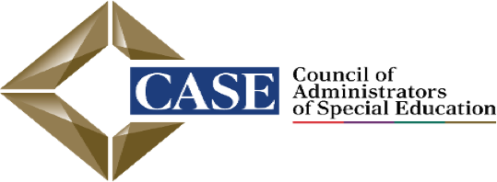
SAVE THE DATE
NORTH CAROLINA CASE ANNUAL FALL CONFERENCE
SEPTEMBER 28 – OCTOBER 1, 2025
Holiday Inn Resort Lumina on Wrightsville Beach

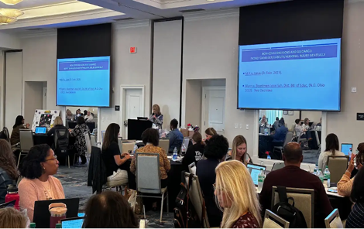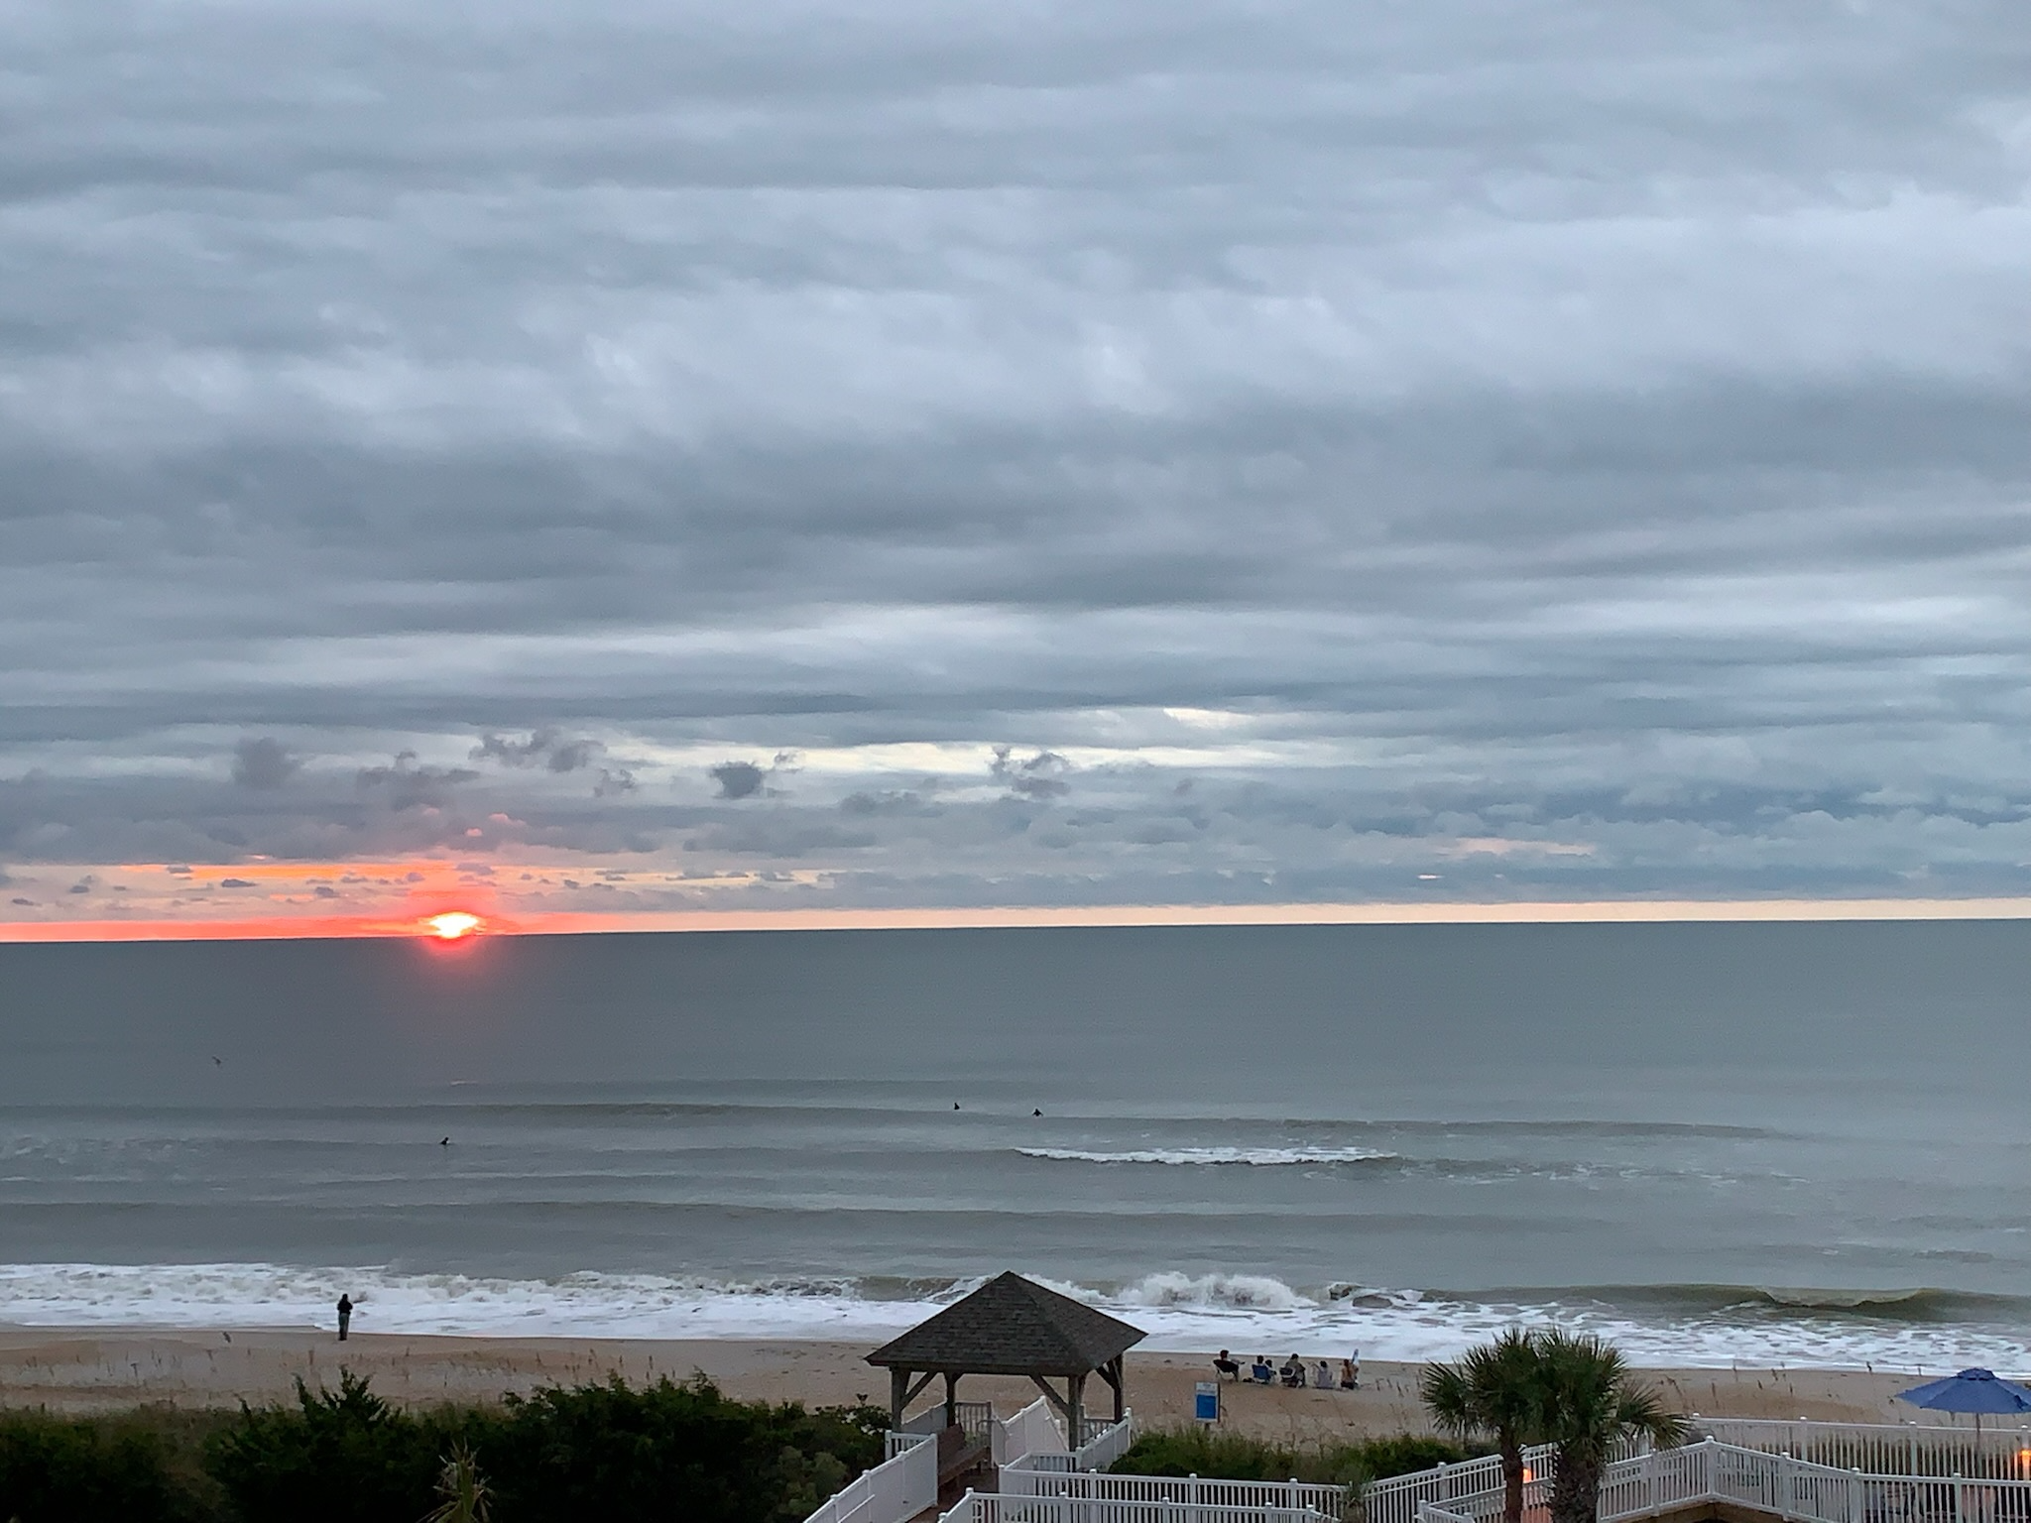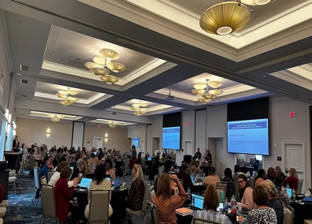
EXCEED THE VISION
BE THE DIFFERENCE
- Build your professional network with leaders in the field of special education in North Carolina.
- Hear from top experts about key issues impacting special education today.
Conference includes breakfast, lunch, and snacks each day.
Conference Rates:
CEC member: $400
Non-Member: $450
Retired EC Director: $250
Guest (meals only): $250
Click here to register: https://forms.gle/76SART7skFyJ5YTs7

Checks made out to NCCASE. Mail to: NCCASE
One University Parkway
Stout School of Education
Drawer 45
ATTN: Teresa Owens
High Point University
High Point NC 27268
For more information on the conference and to book your hotel room at the Holiday Inn Resort Lumina on Wrightsville Beach, visit:www.nccase.org. The hotel block will sell out quickly and end on August 28th so reserve your room early!

